**Task 7: Create Queries**

**Yu Poh Shun**

**Query No. 1**

Purpose: Show daily summary of payment details using report number

1 select p.payment_no, p.amount, p.account_no, r.report_no, r.date_created

2 from payment p, report r

3 where p.report_no = r.report_no and

4 r.report_no = '&report_no';

SQL Queries result

Input example: PR0262

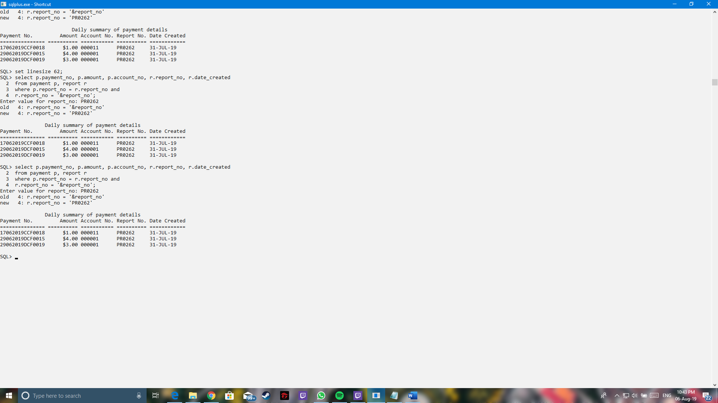

Output:



**Query No. 2**

Purpose: Show account’s reserved books details

1 select a.account_no, a.first_name, a.last_name, r.reserve_no, r.reserve_date, b.book_id, b.book_title

2 from reserve r, loan l, book b, account a

3 where b.book_id=l.book_id and

4 l.reserve_no = r.reserve_no and

5 r.account_no = a.account_no and

6 a.account_no = '&account_no'

7 order by reserve_no;

SQL Queries result

Input example: 000001

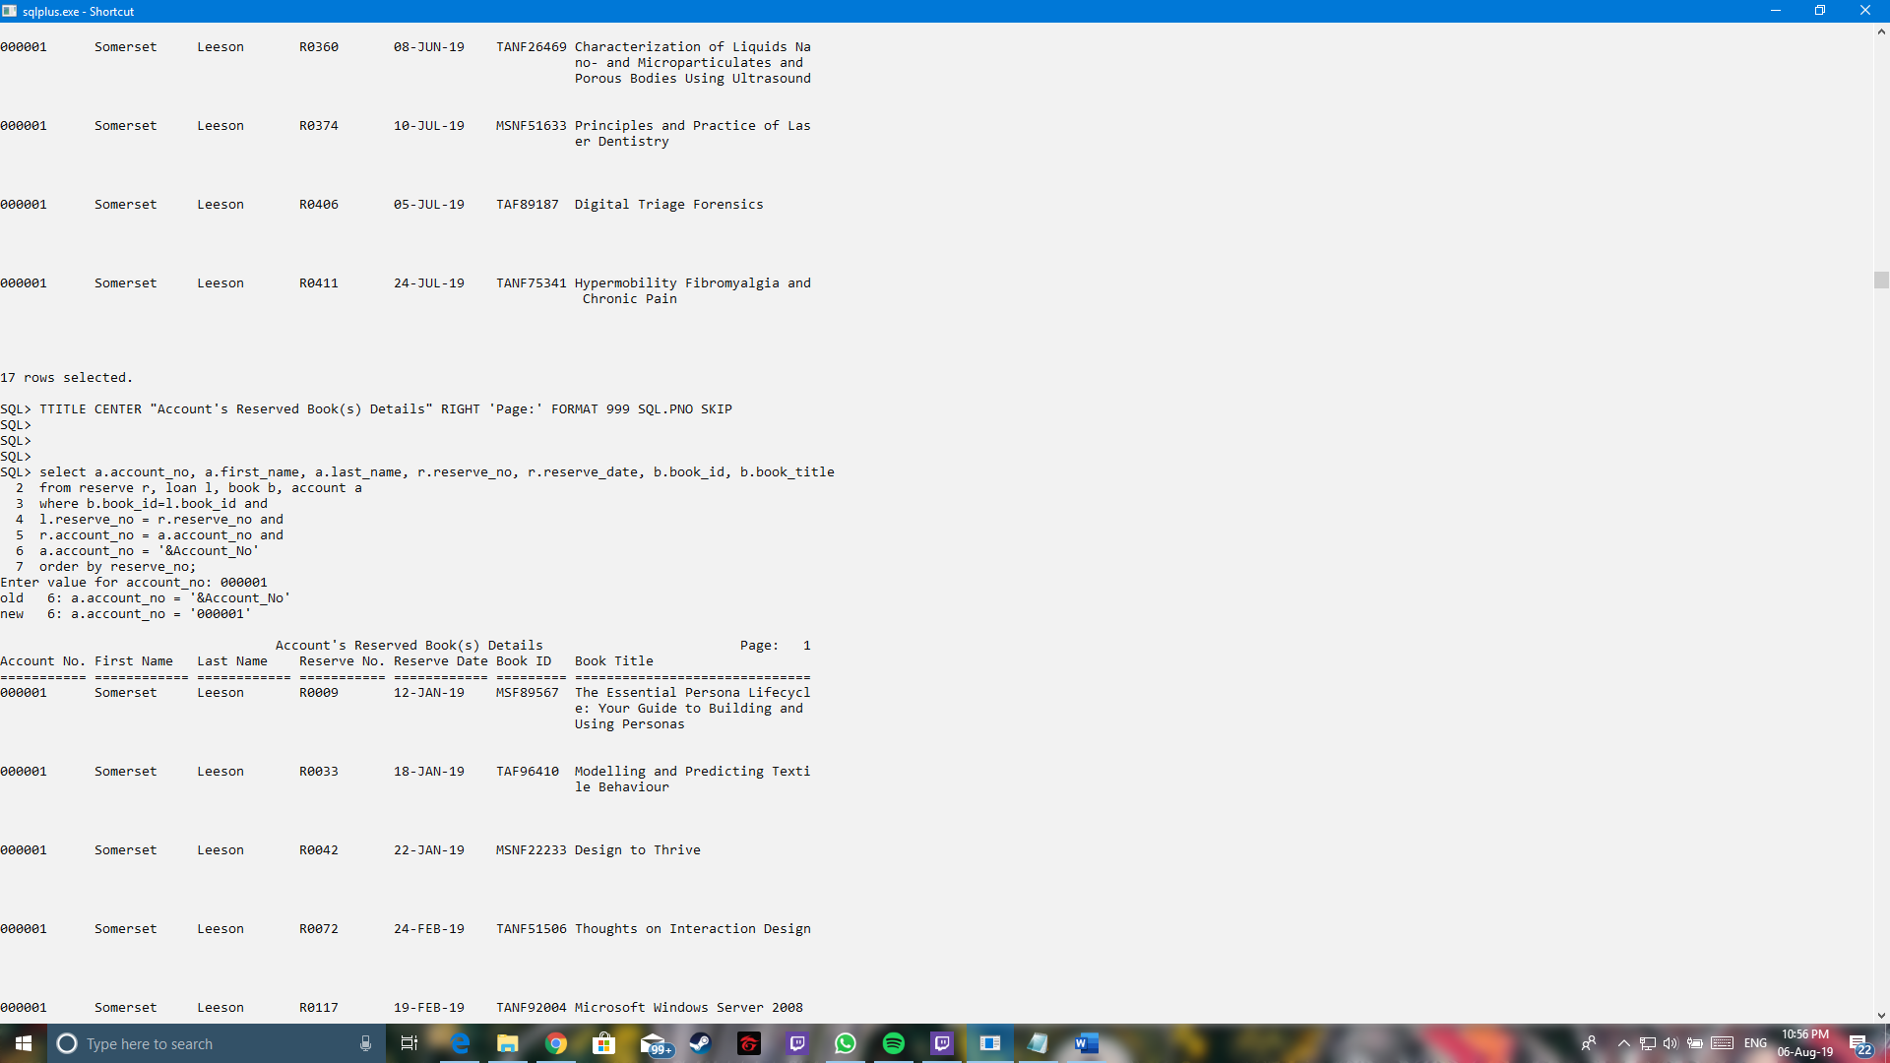

Output:

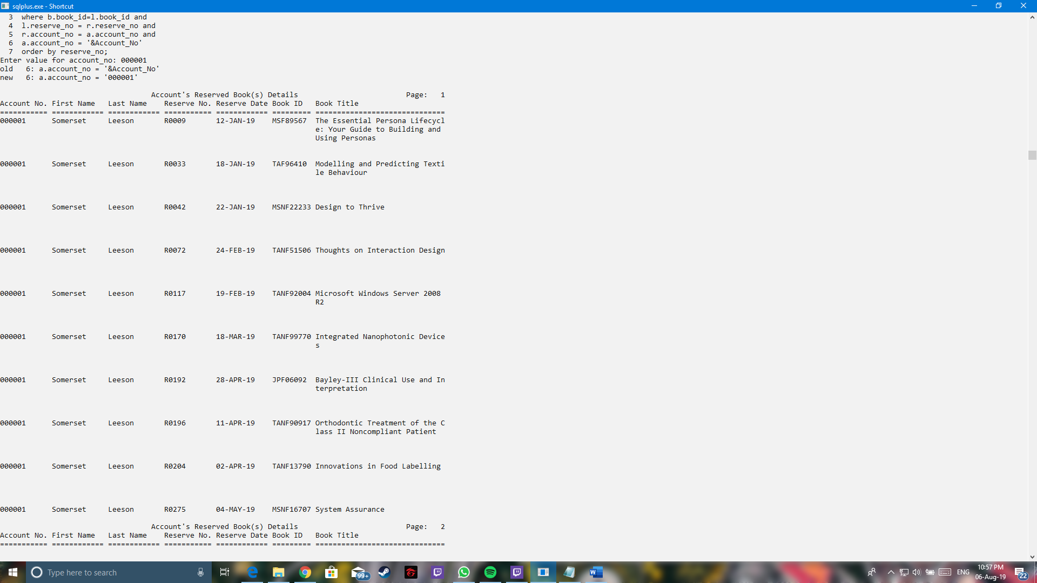

**Query No. 3**

Purpose: Show user’s id book collection date and return date

1 select a.account_no, r.reserve_no, l.book_id, l.collection_date, l.return_date

2 from loan l, reserve r, account a

3 where l.reserve_no = r.reserve_no and

4 r.account_no = a.account_no and

5 a.account_no = '&account_no';

SQL Queries result

Input example: 000001

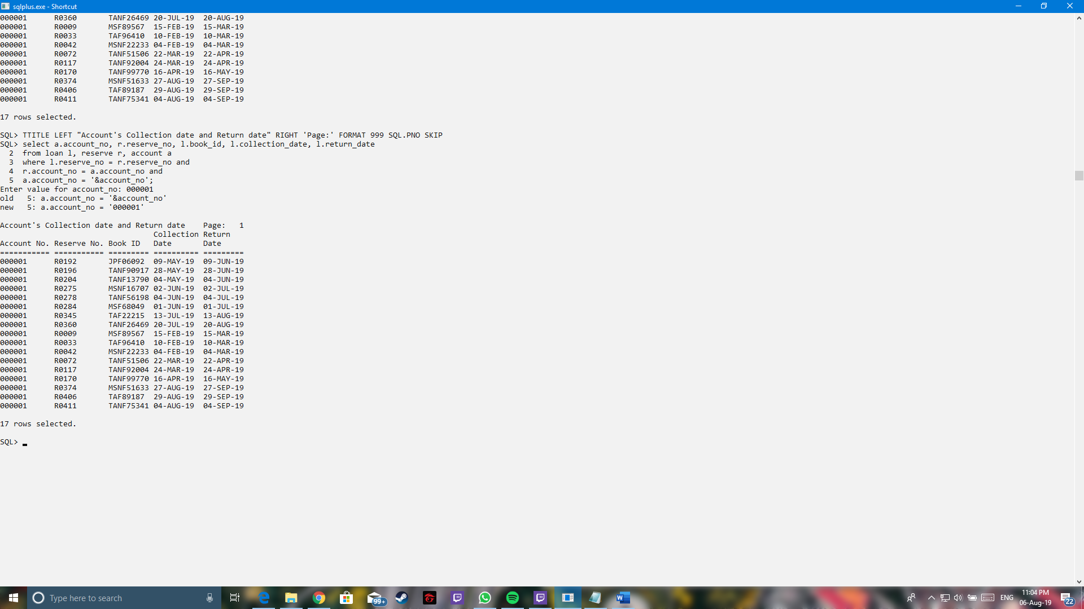

Output:



**Query No. 4**

Purpose: List out number of books by each year

1 select publish_year, count(publish_year) as "Number of Books", to_char(round((count(publish_year)/(select count(*) from book)*100),2),990.99) as "Percentage"

2 from book

3 group by publish_year order by publish_year;

SQL Queries result

Input:

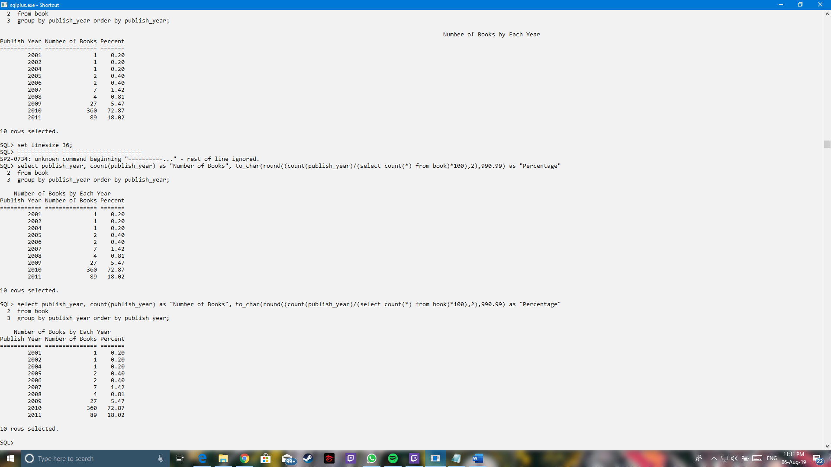

Output:



**Query No. 5**

Purpose: List out fine amount paid by account

1 select f.fine_amount, p.payment_no, f.fine_no, a.account_no

2 from payment p, account a, reserve r, fine f

3 where f.reserve_no = r.reserve_no and

4 r.account_no = a.account_no and

5 a.account_no = p.account_no

SQL Queries result

Input example: 000001

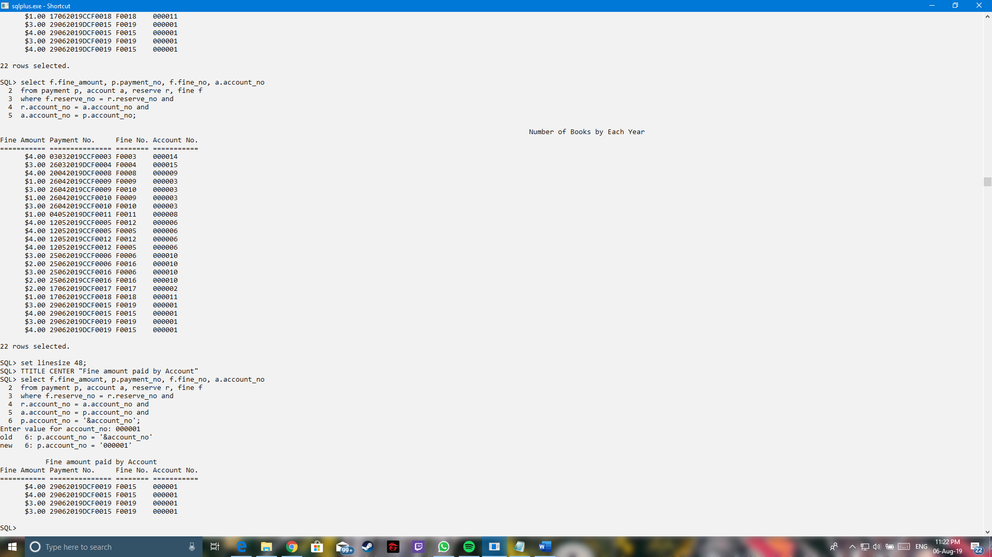

Output:



**Yee Jun Hoong**

**Query No. 1**

Purpose: Show total fine amount by using account number.

1 select sum(F.fine_amount)

2 from Fine F, Account A

3 where A.account_no = ‘&account_no’;

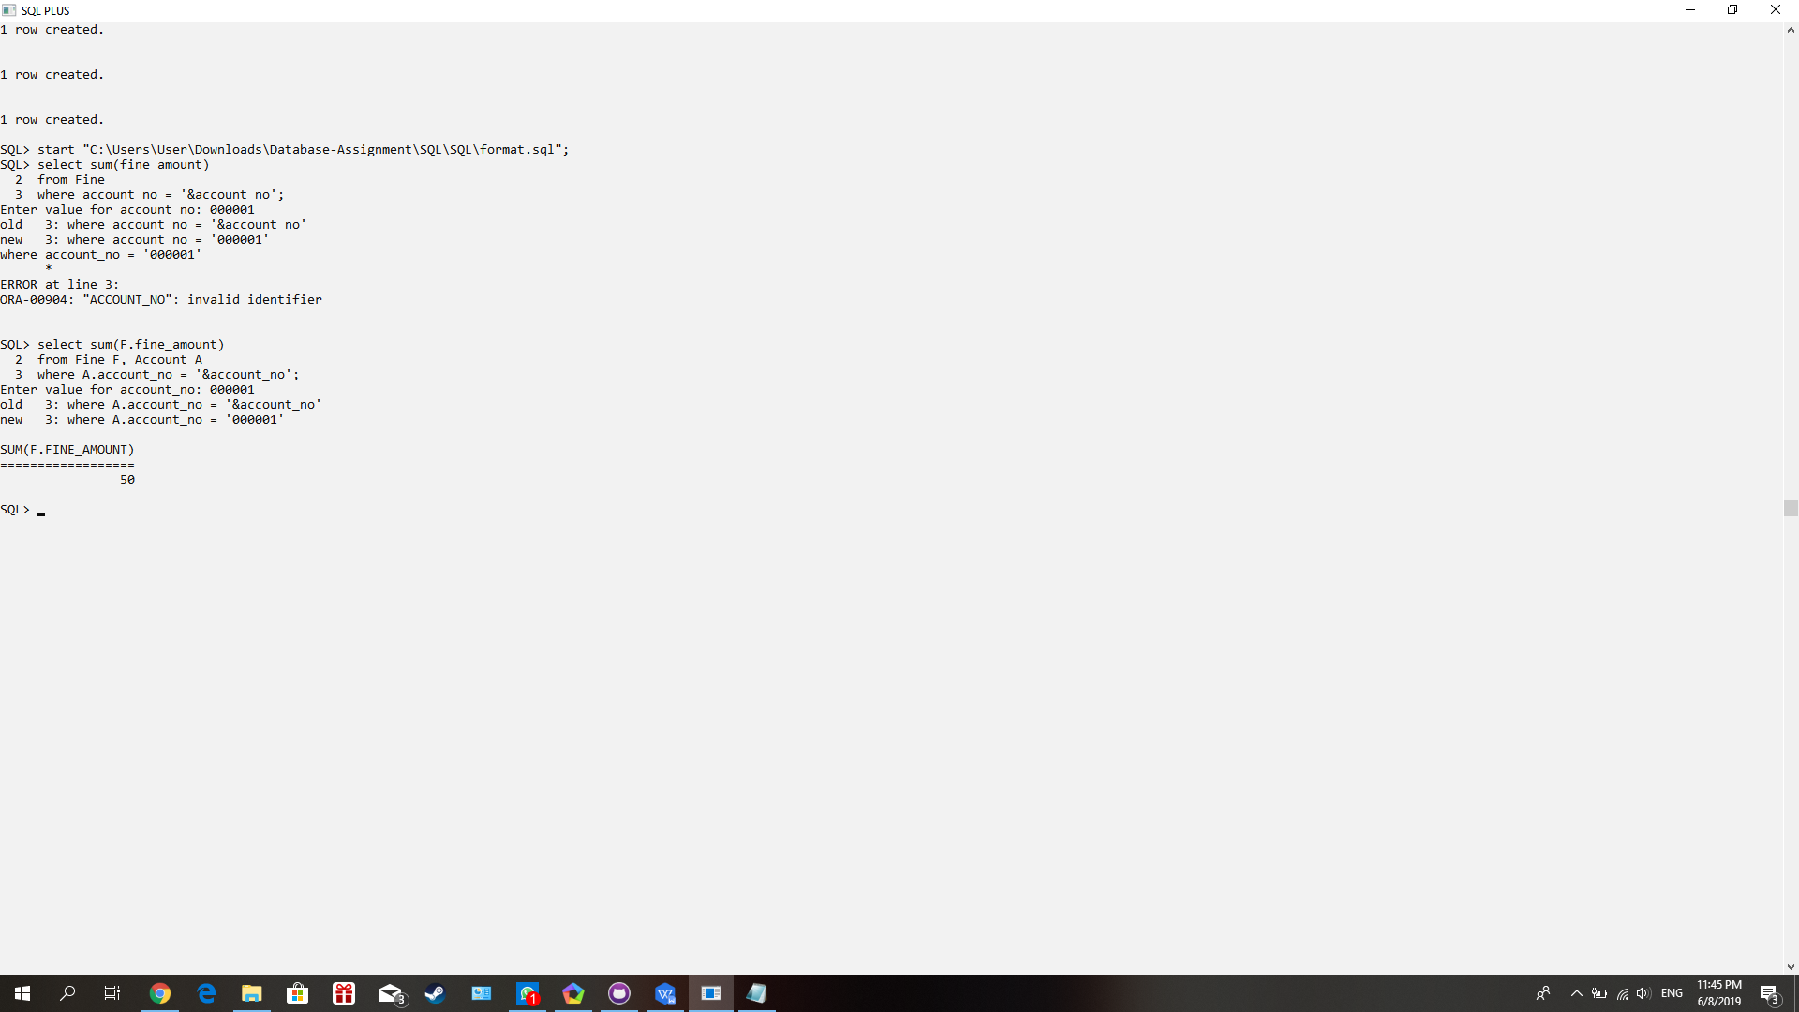

**Query No. 2**

Purpose: Show total payment amount by using account number.

1 select sum(P.amount)

2 from Payment P, Account A

3 where A.account_no = ‘&account_no’;

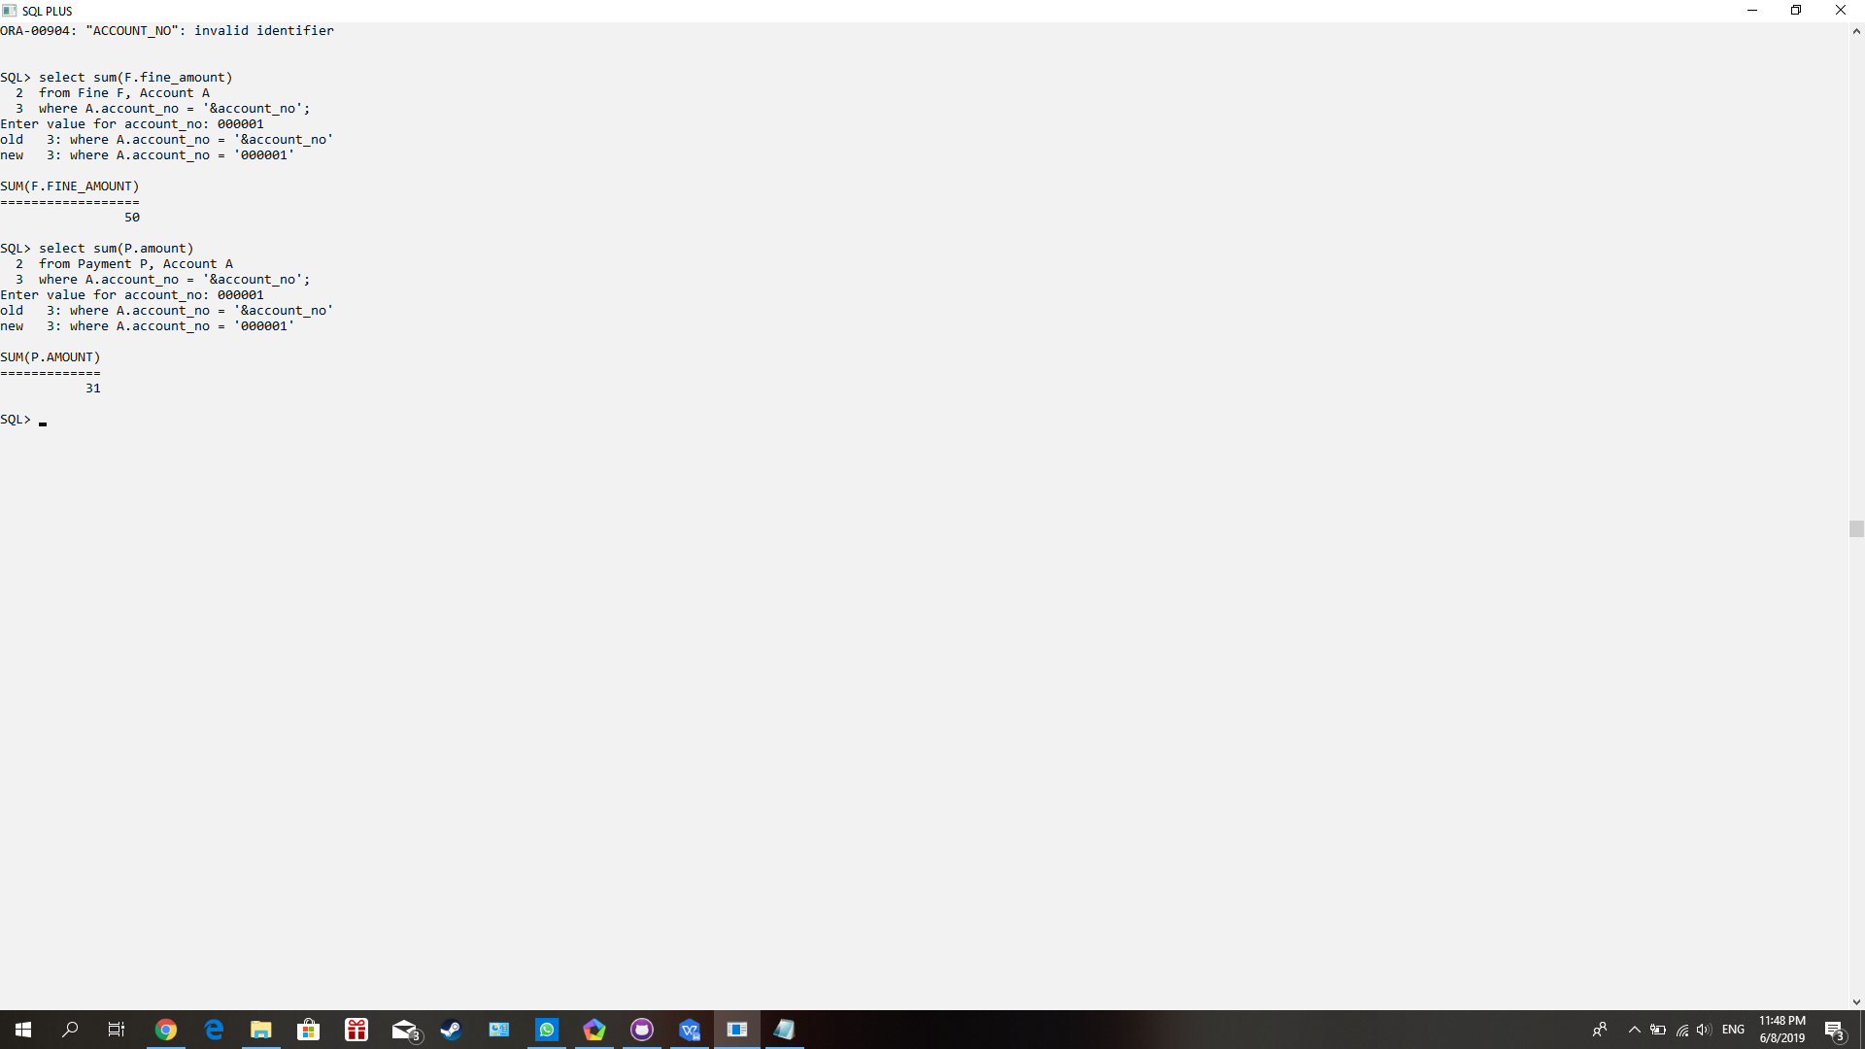

**Query No. 3**

Purpose: Show total and average payment amount per month.

1 select sum(amount), avg(amount)

2 from Payment

3 where sysdate between ‘1 AUGUST 2019’ AND ‘31 AUGUST 2019’;

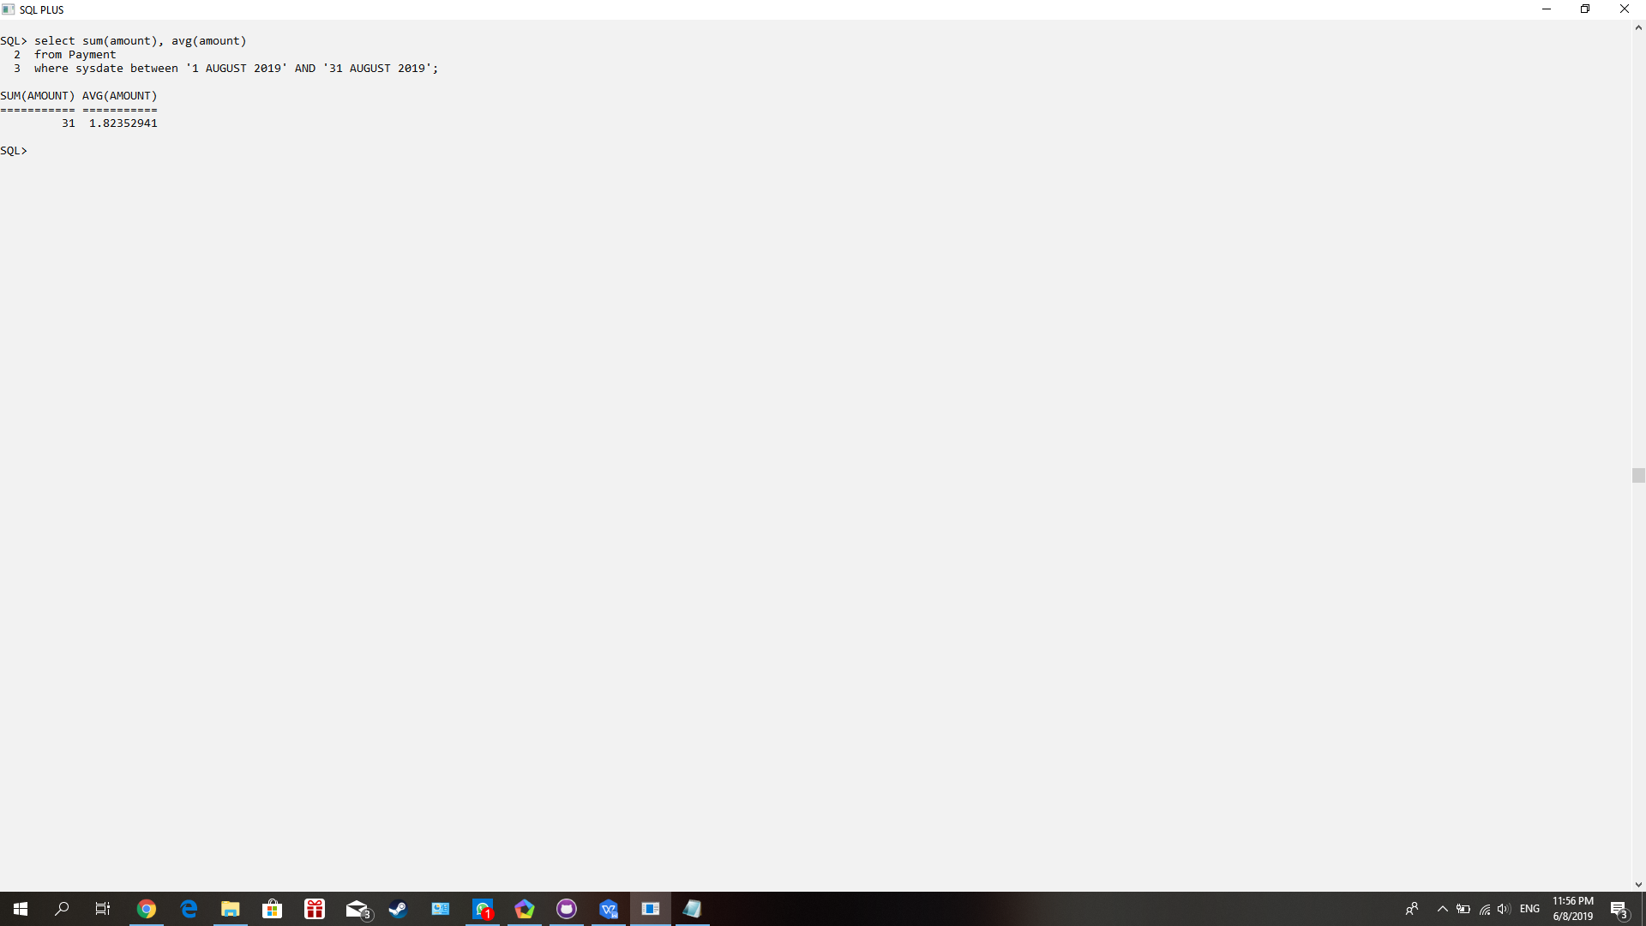

**Query No. 4**

Purpose: Show minimum and maximum of fine amount.

1 select min(fine_amount), max(fine_amount)

2 from Fine;

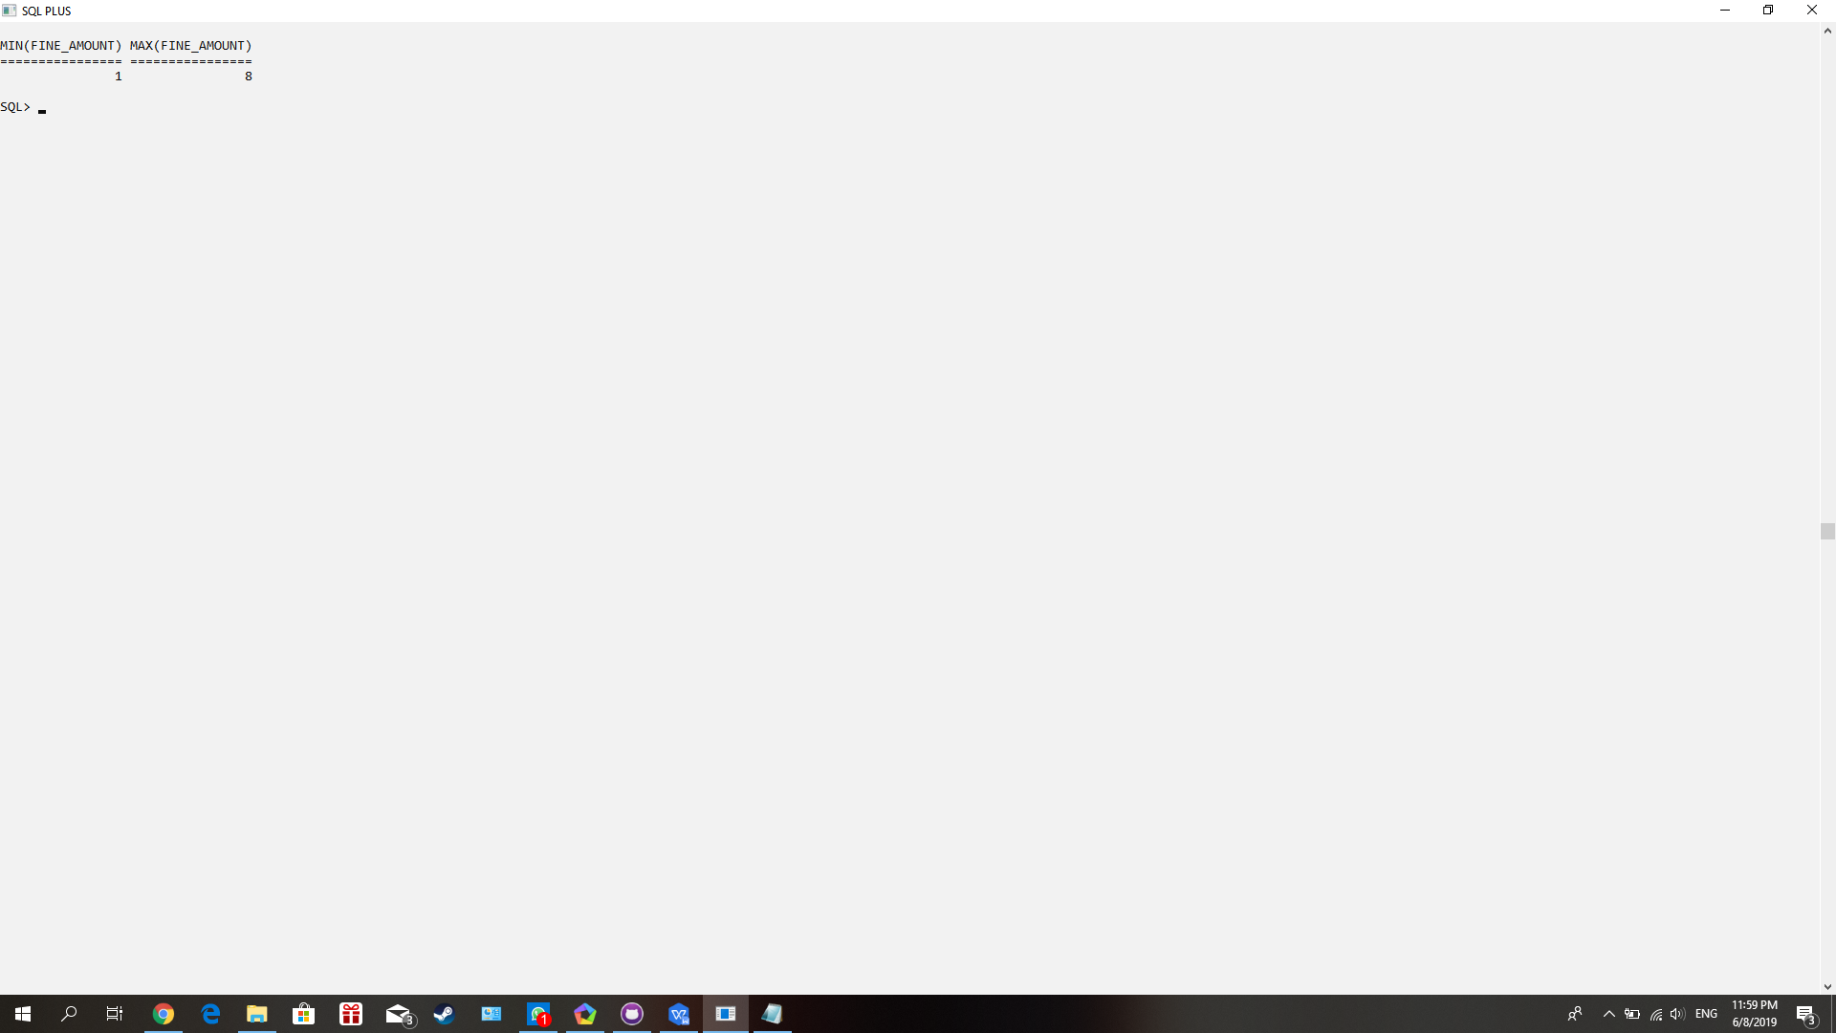

**Query No.5**

Purpose: Show reserve number by using book id through loan

1 select R.reserve_no

2 from Reserve R, Loan L, Book B

3 where B.book_id = L.book_id AND

4 L.reserve_no = R.reserve_no AND

5 B.book_id = ‘&book_id’;

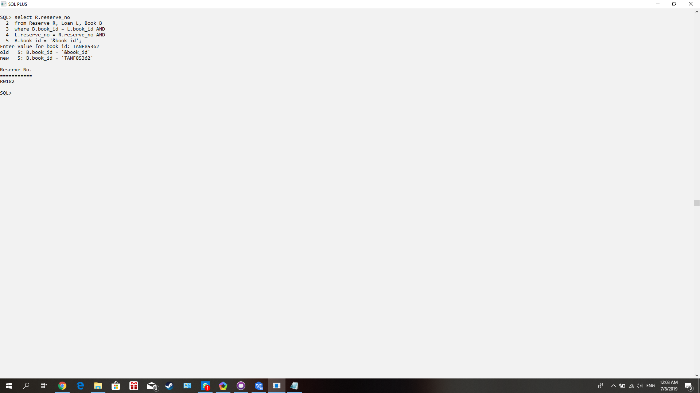

**Query No.6**

Purpose: Show date created of a report by report number

1 select date_created

2 from Report

3 where report_no = ‘&report_no’;

